VOLLEYBALL MANITOBA YOUTH CONCUSSION PROTOCOL
SUMMARY

The following is a summary of the VOLLEYBALL MANITOBA YOUTH CONCUSSION PROTOCOL.

1.) All youth athletes (<18 years of age), parents, coaches, trainers and officials participating in Volleyball Manitoba activities are required to review the Canadian Guideline on Concussion in Sport Pre-season Concussion Education Sheet prior to the first practice of the season. In addition to reviewing information on concussion, it is also important that all sport stakeholders have a clear understanding of the VOLLEYBALL MANITOBA YOUTH CONCUSSION PROTOCOL.

2.) In the event that a Volleyball Manitoba athlete is suspected to have sustained a head injury or concussion the following procedures must be followed:
a) If any athlete is suspected of sustaining a severe head or spine injury during a volleyball-related activity, an ambulance should be called immediately to transfer the patient to Children’s Hospital Emergency Department or the nearest hospital for Medical Assessment. If follow-up care is needed, the patient should follow-up with their primary care provider or a referral can be made to the Pan Am Concussion Program.
b) If the athlete develops symptoms of a concussion during a volleyball game or practice, they must be evaluated immediately at the Children’s Hospital Emergency Department or the nearest emergency room. If follow-up care is needed, the patient should follow-up with their primary care provider or a referral can be made to the Pan Am Concussion Program.

c) If the athlete develops delayed concussion symptoms several hours later, the athlete should be evaluated by their primary care provider.

All athletes with a suspected concussion must provide their coach/teacher with a Canadian Guideline on Concussion in Sport Medical Assessment or Medical Clearance Letter before returning to any volleyball-related activities.
For more information on the VOLLEYBALL MANITOBA YOUTH CONCUSSION PROTOCOL please see below for outline of the complete protocol.

For more information on concussion please visit http://www.parachutecanada.org/injury-topics/item/canadian-guideline-on-concussion-in-sport

VOLLEYBALL MANITOBA YOUTH CONCUSSION PROTOCOL

In collaboration with Sport Manitoba, VOLLEYBALL MANITOBA has developed the VOLLEYBALL MANITOBA YOUTH CONCUSSION PROTOCOL to help guide the management of athletes who may have a suspected concussion as a result of participation in volleyball-related activities.

Purpose
This protocol covers the recognition, medical diagnosis, and management of athletes who may sustain a suspected concussion during a sport activity. It aims to ensure that athletes with a suspected concussion receive timely and appropriate care and proper management to allow them to return back to their sport safely. This protocol may not address every possible clinical scenario that can occur during volleyball-related activities but includes critical elements based on the latest evidence and current expert consensus.

Application to non-sport related concussion
This guideline has been adapted from the Canadian Guideline on Concussion in Sport. However, the management principles described in these guidelines should also be applied to children and adolescents who sustain a concussion outside of a sporting activity and are returning to sports.

Who should use this protocol?
This guideline is intended for use by all individuals who interact with youth inside and outside the context of school and non-school based organized sports activity, including athletes, parents, coaches, officials, teachers, trainers, and licensed healthcare professionals.

Recommendations

1. Pre-Season Education

Despite recent increased attention focusing on concussion there is a continued need to improve concussion education and awareness. Optimizing the prevention and management of concussion depends highly on annual education of all sport stakeholders (athletes, parents, coaches, officials, teachers, trainers, licensed healthcare professionals) on current evidence-informed approaches that can prevent concussion and more serious forms of head injury and help identify and manage an athlete with a suspected concussion.

Concussion education should include information on:
- the definition of concussion,
- possible mechanisms of injury,
- common signs and symptoms,

- steps that can be taken to prevent concussions and other injuries from occurring in sport.
- what to do when an athlete has suffered a suspected concussion or more serious head injury,
- what measures should be taken to ensure proper medical assessment,
- Return-to-School and Return-to-Sport Strategies, and
- Return-to-Sport medical clearance requirements

Who: Athletes, parents, coaches, officials, teachers, and trainers, licensed healthcare professionals
How: Canadian Guideline on Concussion in Sport Pre-season Concussion Education Sheet

All athletes, parents, coaches, trainers, and officials are required to review the Canadian Guideline on Concussion in Sport Pre-season Concussion Education Sheet prior to the first practice of each season. In addition to reviewing information on concussion, it is also important that all sport stakeholders have a clear understanding of the VOLLEYBALL MANITOBA YOUTH CONCUSSION PROTOCOL.

2. Head Injury Recognition

Although the formal diagnosis of concussion should be made following a medical assessment, all sport stakeholders including athletes, parents, teachers, coaches, teachers, officials, and licensed healthcare professionals are responsible for the recognition and reporting of athletes who may demonstrate visual signs of a head injury or who report concussion-related symptoms. This is particularly important because many sport and recreation venues will not have access to on-site licensed healthcare professionals.

A concussion should be suspected:
- in any athlete who sustains a significant impact to the head, face, neck, or body and demonstrates ANY of the visual signs of a suspected concussion or reports ANY symptoms of a suspected concussion as detailed in the Concussion Recognition Tool 5.
- if an athlete reports ANY concussion symptoms to one of their peers, parents, teachers, or coaches or if anyone witnesses a student exhibiting any of the visual signs of concussion.

In some cases, an athlete may demonstrate signs or symptoms of a more severe head or spine injury including convulsions, worsening headaches, vomiting or neck pain. If an athlete demonstrates any of the ‘Red Flags’ indicated by the Concussion Recognition Tool 5, a more severe head or spine injury should be suspected.

Who: Athletes, parents, coaches, officials, teachers, trainers, and licensed healthcare professionals
How: Concussion Recognition Tool 5

3. Onsite Medical Assessment

Depending on the suspected severity of the injury, an initial assessment may be completed by emergency medical professionals or by an on-site licensed health professional where available.

3a. Emergency Medical Assessment

If an athlete is suspected of sustaining a more severe head or spine injury during a game or practice, an ambulance should be called immediately to transfer the athlete to the nearest emergency department for further Medical Assessment. Coaches, parents, teachers, trainers and officials should not make any effort to remove equipment or move the athlete until an ambulance has arrived and the athlete should not be left alone until the ambulance arrives. After the emergency medical services staff has completed the Emergency Medical Assessment, the athlete should be transferred to the nearest hospital for Medical Assessment. In addition, the athlete’s parents should be contacted immediately to inform them of the athlete’s injury.

Who: Emergency medical professionals

3b. Sideline Medical Assessment

If an athlete is suspected of sustaining a concussion and there is no concern for a more serious head or spine injury, the athlete should be immediately removed from the field of play. If a licensed healthcare professional is present, the athlete should be taken to a quiet area and undergo Sideline Medical Assessment using the Sport Concussion Assessment Tool-5 (SCAT5) or the Child SCAT5. The SCAT5 and Child SCAT5 are clinical tools that should only be used by a licensed medical professional that has experience using these tools. It is important to note that the results of SCAT5 and Child SCAT5 testing can be normal in the setting of acute concussion. As such, these tools can be used by licensed healthcare professionals to document initial neurological status but should not be used to make sideline return-to-sport decisions in youth athletes. Any athlete who is suspected of having sustained a concussion must not return to the game or practice and must be referred to a medical doctor, nurse practitioner or physician assistant for Medical Assessment.

If an athlete is removed from play following a significant impact but there are NO visual signs of a concussion and the athlete reports NO concussion symptoms

then the athlete can be returned to play but should be monitored for delayed symptoms.

Who: Athletic therapists, physiotherapists, medical doctor
How: Sport Concussion Assessment Tool 5 (SCAT5), Child Sport Concussion Assessment Tool 5 (Child SCAT5)

4. Medical Assessment

In order to provide comprehensive evaluation of athletes with a suspected concussion, the Medical Assessment must rule out more serious forms of traumatic brain and spine injuries, must rule out medical and neurological conditions that can present with concussion-like symptoms, and must make the diagnosis of concussion based on findings of the clinical history and physical examination and the evidence-based use of adjunctive tests as indicated (i.e CT scan). In addition to nurse practitioners and physician assistants, medical doctors that are qualified to evaluate patients with a suspected concussion include pediatricians, family medicine, sports medicine, emergency department and rehabilitation (physiatrists) physicians as well as neurologists and neurosurgeons. In geographic regions of Manitoba or Canada with limited access to medical doctors (i.e. rural or northern communities), a licensed healthcare professional (i.e. nurse) with pre-arranged access to a medical doctor or nurse practitioner can facilitate this role. The Medical Assessment is responsible for determining whether the athlete has been diagnosed with a concussion or not. All athletes with a diagnosed concussion should be provided with a Canadian Guideline on Concussion in Sport Medical Assessment Letter indicating a concussion has been diagnosed. Athletes that are determined to have not sustained a concussion must be provided with a Medical Assessment Letter indicating a concussion has not been diagnosed and the athlete can return to school, work and sports activities without restriction.

Who: Medical doctor, nurse practitioner, physician assistant, nurse
How: Canadian Guideline on Concussion in Sport Medical Assessment Letter
5. Concussion Management

When an athlete has been diagnosed with a concussion, it is important that the athlete’s parent/legal guardian is informed. All athletes diagnosed with a concussion must be provided with a standardized Canadian Guideline on Concussion in Sport Medical Assessment Letter that notifies the athlete and their parents/legal guardians/spouse that they have been diagnosed with a

concussion and may not return to any activities with a risk of concussion until medically cleared to do so by a medical doctor, nurse practitioner, or physician assistant. Because the Medical Assessment Letter contains personal health information, it is the responsibility of the athlete or their parent/legal guardian to provide this documentation to the athlete’s coaches, trainers, teachers, or employers. It is also important for the athlete to provide this information to sport or school organization officials that are responsible for injury reporting and concussion surveillance where applicable.

All athletes diagnosed with a concussion should be provided with education about the signs and symptoms of concussion, strategies about how to manage their symptoms, the risks of returning to sport without medical clearance and recommendations regarding a gradual return to school and sport activities. Athletes diagnosed with a concussion are to be managed according to their Return-to-School and Sport-Specific Return-to-Sport Strategy under the supervision of a medical doctor, nurse practitioner, or physician assistant. When available, athletes should be encouraged to work with the team athletic therapist or physiotherapist to optimize progression through their Sport-Specific Return-to-Sport Strategy. Once the athlete has completed their Return-to-School and Sport-Specific Return-to-Sport Strategy and are deemed to be clinically recovered from their concussion, the medical doctor, nurse practitioner, or physician assistant can consider the athlete for a return to full sports activities.

Return-to-School Strategy

The following is an outline of the Return-to-School Strategy that should be used to help athletes, parents, and teachers to collaborate in allowing the athlete to make a gradual return to school activities. Depending on the severity and type of the symptoms present athletes will progress through the following stages at different rates. If the athlete experiences new symptoms or worsening symptoms at any stage, they should go back to the previous stage.

Stage | Aim | Activity | Goal of each step
1 | Daily activities at home that do not give the student-athlete symptoms | Typical activities of the child during the day as long as they do not increase symptoms (i.e. reading, texting, screen time)  Start at 5-15 minutes at a time and gradually build up | Gradual return to typical activities
2 | School activities | Homework, reading or other cognitive activities outside of the classroom | Increase tolerance to cognitive work
3 | Return to school part-time | Gradual introduction of schoolwork. May need to start with a partial school day or with increased breaks during the day | Increase academic activities
4 | Return to school full-time | Gradually progress | Return to full academic activities and catch up on missed school work

Return-to-Sport Strategy (Volleyball)

The following is an outline of the Return-to-Sport Strategy that should be used to help athletes, coaches, trainers, teachers and medical professionals to partner in allowing the athlete to make a gradual return to sport activities. An initial period of 24-48 hours of rest is recommended before starting the Sport-Specific Return-to-Sport Strategy. If the athlete experiences new symptoms or worsening symptoms at any stage, they should go back to the previous stage. It is important that athletes return to full-time school activities before progressing to stage 5 and 6 of the Sport-Specific Return-to-Sport Strategy. It is also important that all athletes provide their coach with a Canadian Guideline on Concussion in Sport Medical Clearance Letter prior to returning to full contact sport activities.

Stage | Aim | Activity | Goal of each step
1 | Symptom-limiting activity | Daily activities that do not provoke symptoms | Gradual re-introduction of work/school activities
2 | Light aerobic activity | Walking or stationary cycling at slow to medium pace. No resistance training | Increase heart rate
3 | Sport-specific exercise | Low to moderate intensity individual running and agility drills. Individual bumping, serving, setting. No team drills or head impact activities | Add movement
4 | Non-contact training drills | High intensity running, and agility drills. Individual and small group serve receive, digging, spiking, blocking drills. May start progressive resistance training. No head impact activities | Exercise, coordination and increased thinking
5 | Full contact practice | Following medical clearance  High intensity full team practices and scrimmages | Restore confidence and assess functional skills by coaching staff
6 | Return to sport | Normal game play

Who: Medical doctor, nurse practitioner, physician assistant and team athletic therapist or physiotherapist (where available)
How: Return-to-Learn Strategy, Sport-Specific Return-to Sport Strategy, Canadian Guideline on Concussion in Sport Medical Assessment Letter, Canadian Guideline on Concussion in Sport Medical Clearance Letter

6. Multidisciplinary Concussion Care

Most athletes who sustain a concussion while participating in sport will make a complete recovery and be able to return to full school and sport activities within 1-4 weeks of injury. However, approximately 15-30% of individuals will experience symptoms that persist beyond this time frame. Youth athletes who experience persistent post-concussion symptoms (>4 weeks) may benefit from their primary care provider making a referral to the Pan Am Concussion Program, a medically-supervised multi-disciplinary pediatric concussion clinic that has access to professionals with licensed training in traumatic brain injury that include experts in neurosurgery, sport medicine, neuropsychology, physiotherapy, and neurology.

Referral to a multidisciplinary clinic for assessment should be made on an individualized basis at the discretion of the athlete’s medical doctor, nurse practitioner, or physician assistant.

Who: Multidisciplinary medical team, medical doctor with clinical training and experience in concussion (e.g. a sports medicine physician, neurosurgeon, or rehabilitation medicine physician), licensed healthcare professionals

7. Return to Sport

Athletes who have been determined to have not sustained a concussion and those that have been diagnosed with a concussion and have successfully completed their Return-to-School and Sport-Specific Return-to-Sport Strategy can be considered for return to full sports activities. The final decision to medically clear an athlete to return to full game activity should be based on the clinical judgment of the medical doctor, nurse practitioner, or physician assistant taking into account the athlete’s past medical history, clinical history, physical examination findings and the results of other tests and clinical consultations where indicated (i.e neuropsychological testing, diagnostic imaging). Prior to returning to full contact practice and game play, each athlete that has been diagnosed with a concussion must provide their coach/teacher with a standardized Canadian Guideline on Concussion in Sport Medical Clearance Letter that specifies that a medical doctor, nurse practitioner, or physician assistant has personally evaluated the athlete and has cleared the athlete to return to sports. In geographic regions of Manitoba and Canada with limited access to medical doctors (i.e. rural or northern communities), a licensed healthcare professional (such as a nurse) with pre-arranged access to a medical doctor or nurse practitioner can provide this documentation. A copy of the Canadian Guideline on Concussion in Sport Medical Clearance Letter should also be submitted to sports organization officials that have injury reporting and surveillance programs where applicable.

Athletes who have been provided with a Medical Clearance Letter may return to full sport activities as tolerated. If the athlete experiences any new concussion-like symptoms while returning to play, they should be instructed to stop playing immediately, notify their parents, coaches, trainer or teachers, and undergo follow-up Medical Assessment. In the event that the athlete sustains a new suspected concussion, the VOLLEYBALL MANITOBA YOUTH CONCUSSION PROTOCOL should be followed as outlined here.

Who: Medical doctor, nurse practitioner, physician assistant
Document: Canadian Guideline on Concussion in Sport Medical Clearance Letter

For more information on concussion and how to download the Concussion Recognition Tool 5, SCAT5 & Child SCAT5 please visit http://www.parachutecanada.org/injury-topics/item/canadian-guideline-on-concussion-in-sport

VOLLEYBALL MANITOBA YOUTH CONCUSSION PATHWAY
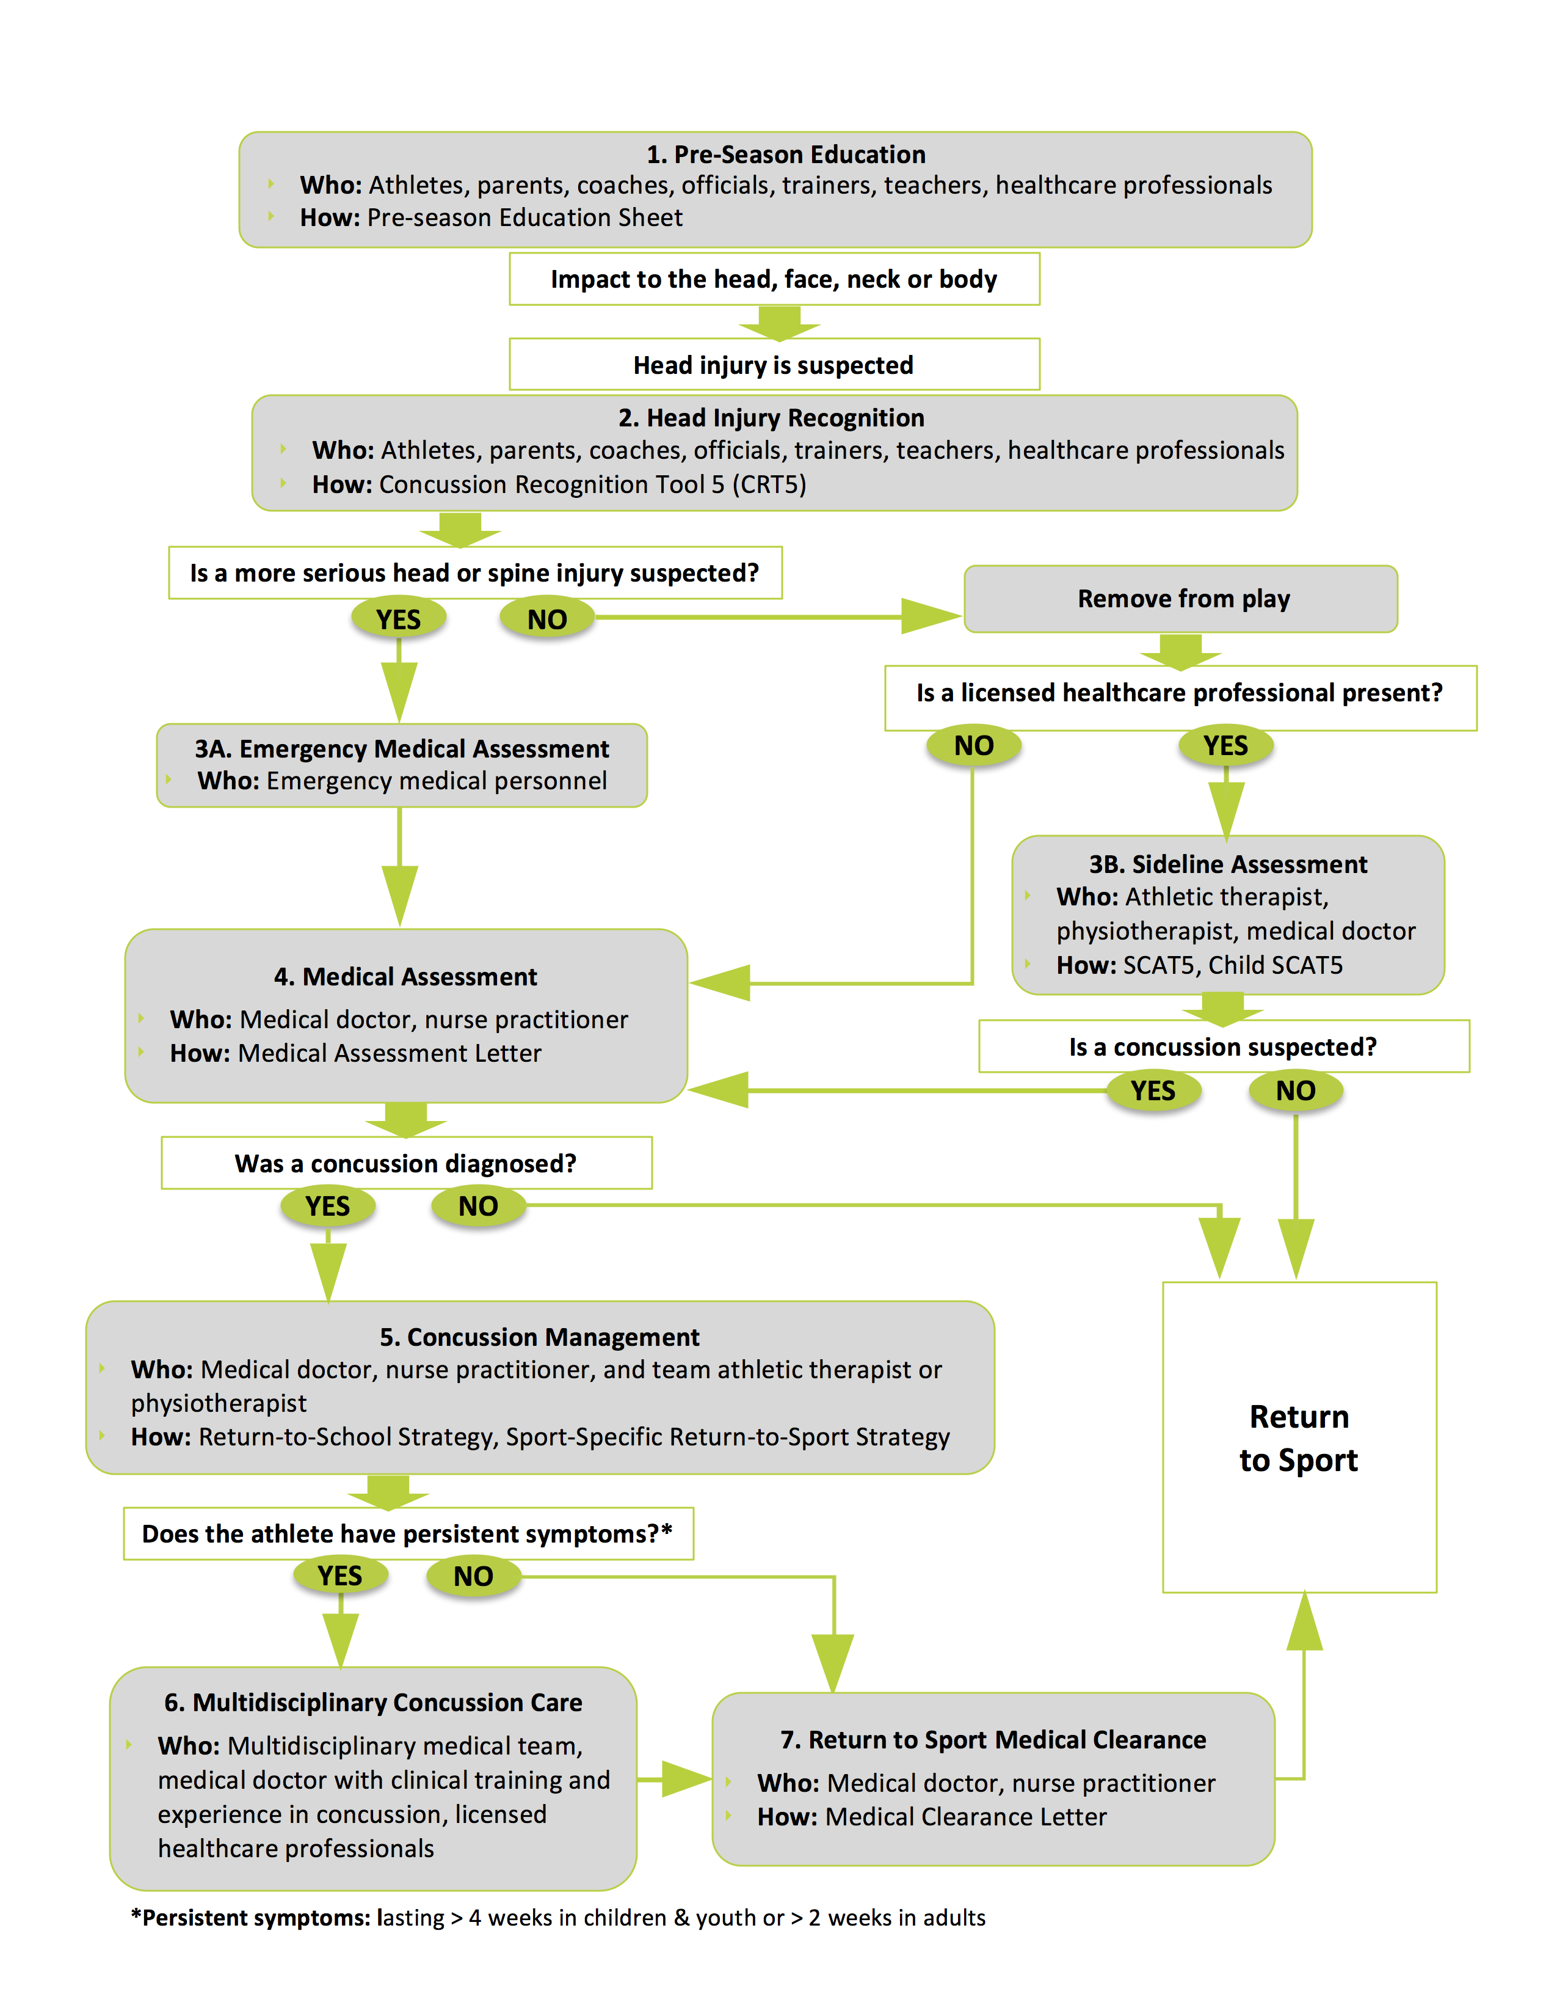

Medical doctors and nurse practitioners are the only healthcare professionals in Canada with licensed training and expertise to meet these needs; therefore all athletes with a suspected concussion should undergo evaluation by one of these professionals.

